* Following is the AWS Platform diagram:

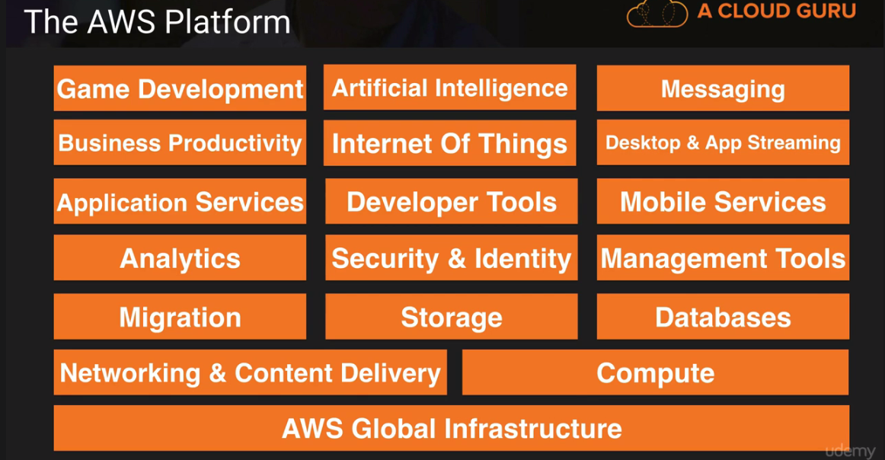

* AWS never initiate the movement of data b/w regions unless customer explicitly enable it. AWS infrastructure contains

1) Region

2) Availability Zone

3) **Edge Location** which are CDN/cached (Content delivery n/w) endpoint for **cloud front**

* Route 53 is DNS service as 53 is DNS port while Direct Connect is direct connection b/w AWS and enterprise n/w.
* 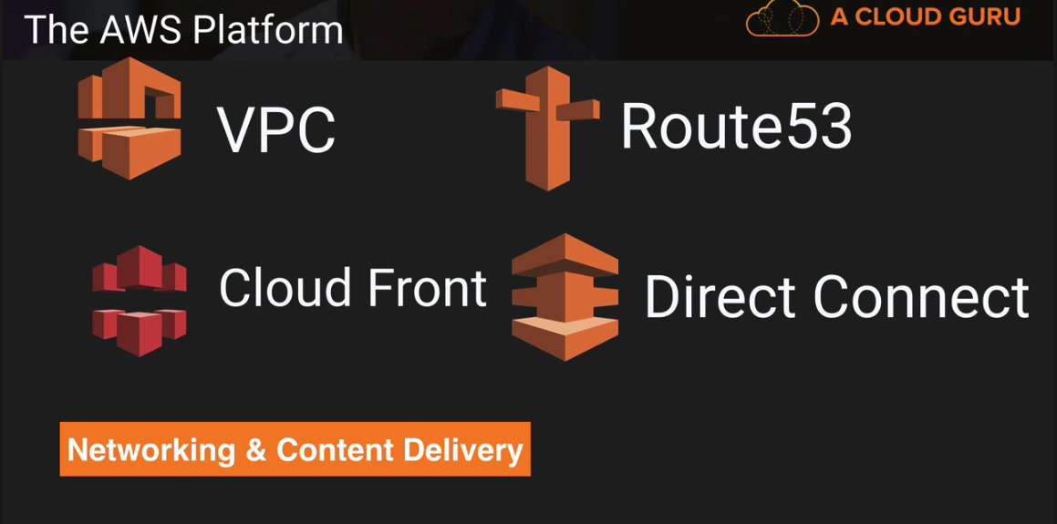 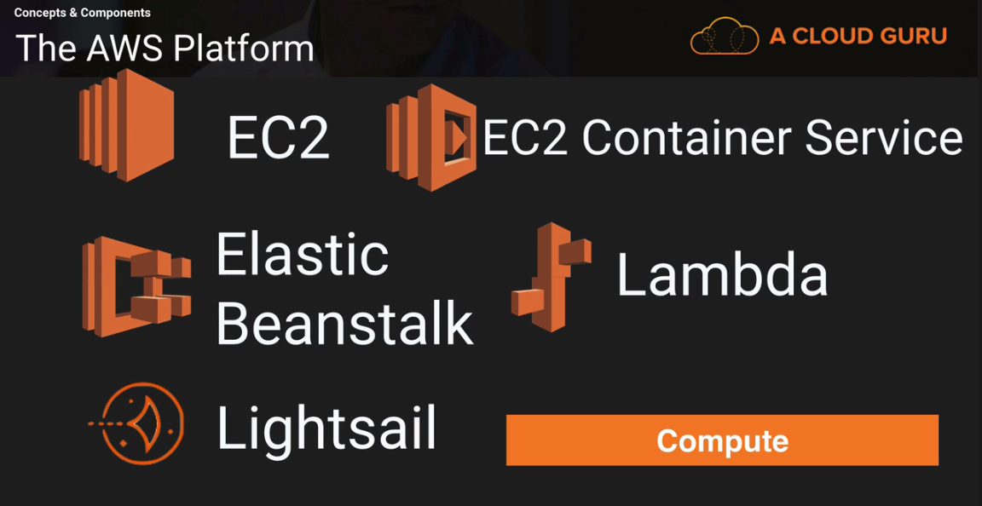
* **LightSail** is out of the box cloud to deploy WordPress or Jumla site for you automatically.
* **Glacier** stores archived files from S3. While **Storage Gateway** connects enterprise’s private n/w with cloud S3 via VM machine image.
* 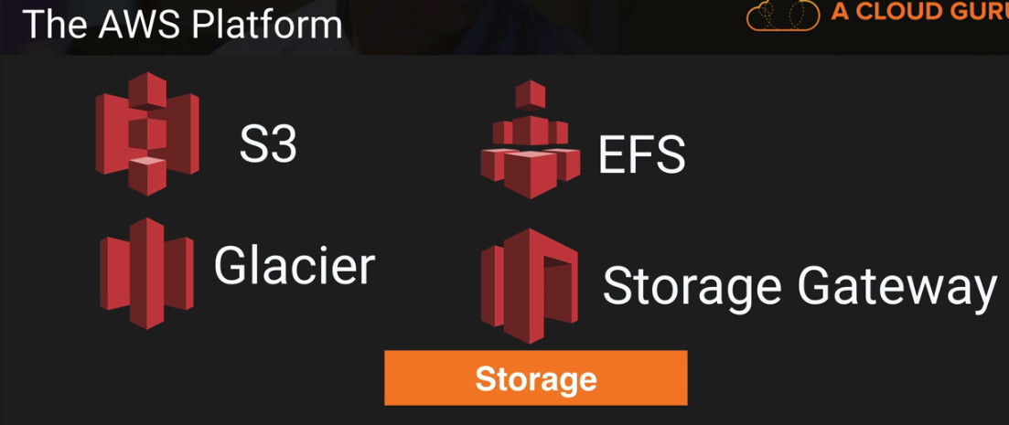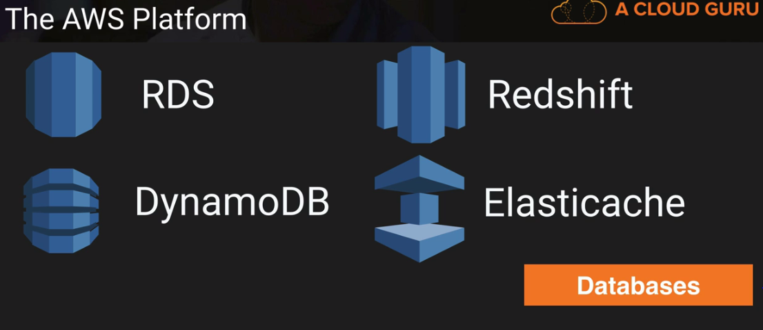
* **Snowball** (edge) migrate data by import/export from hard-disk while **DMS**(Database) migrates data from DB w/o downtime.

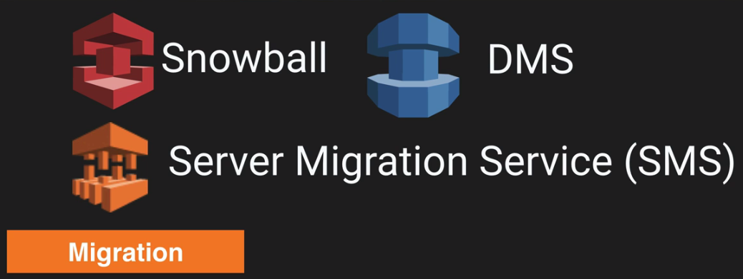 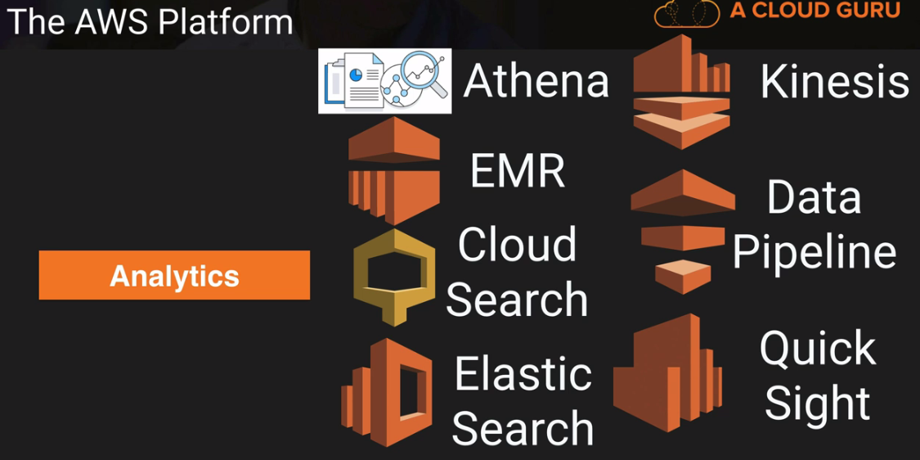

* **Athena** is tool to run SQL query on S3 data while **EMR** (elastic map reduce) is for analyzing Big Data like logs same as Kinesis. **Cloud Search** is fully managed service while **Elastic Search** are based on Open source. **Kinesis** is used for collating large amounts of data streamed from multiple sources. **Data Pipeline** is used to flow data from S3 to DynamoDB while **Quick Sight** is used to create dashboard for data.
* **Cloud watch** monitors health of EC2.
* 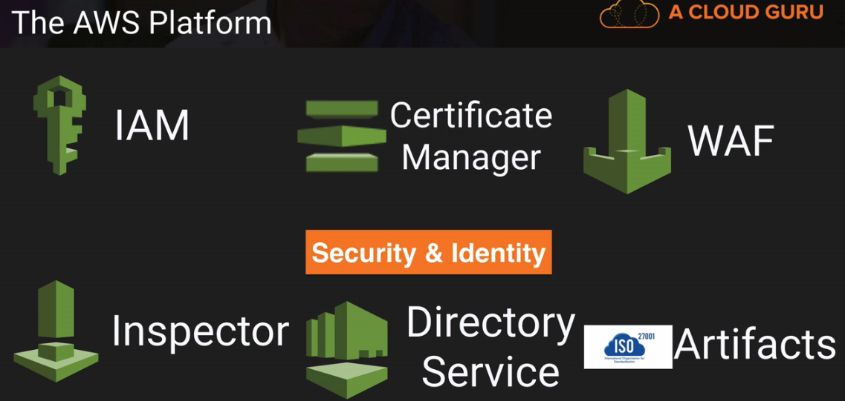 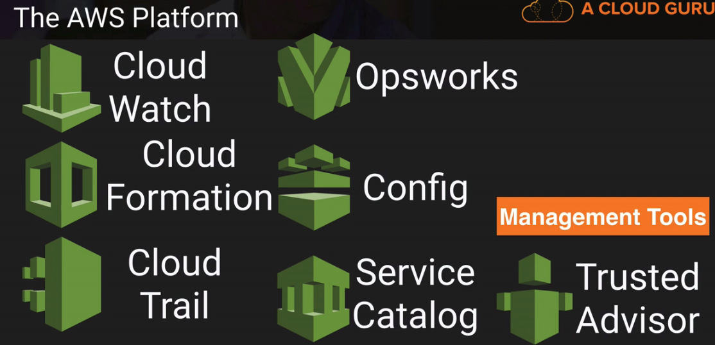

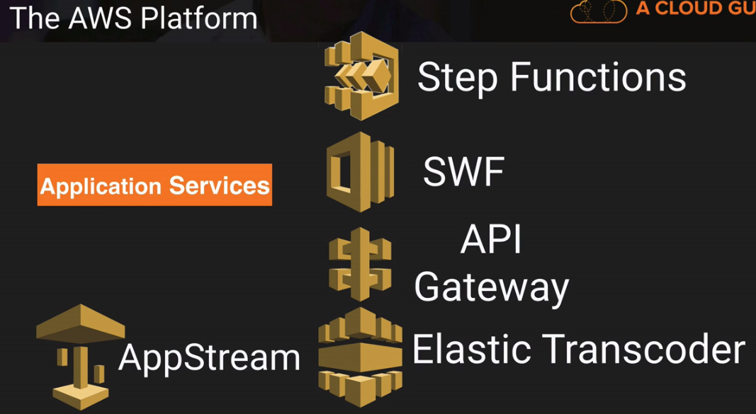 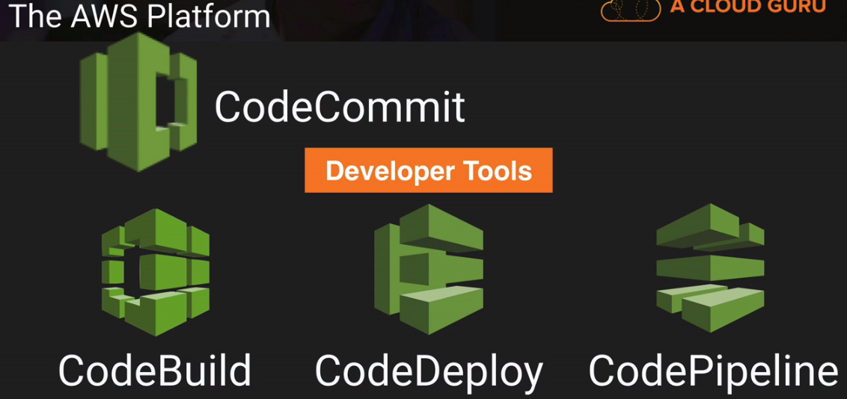

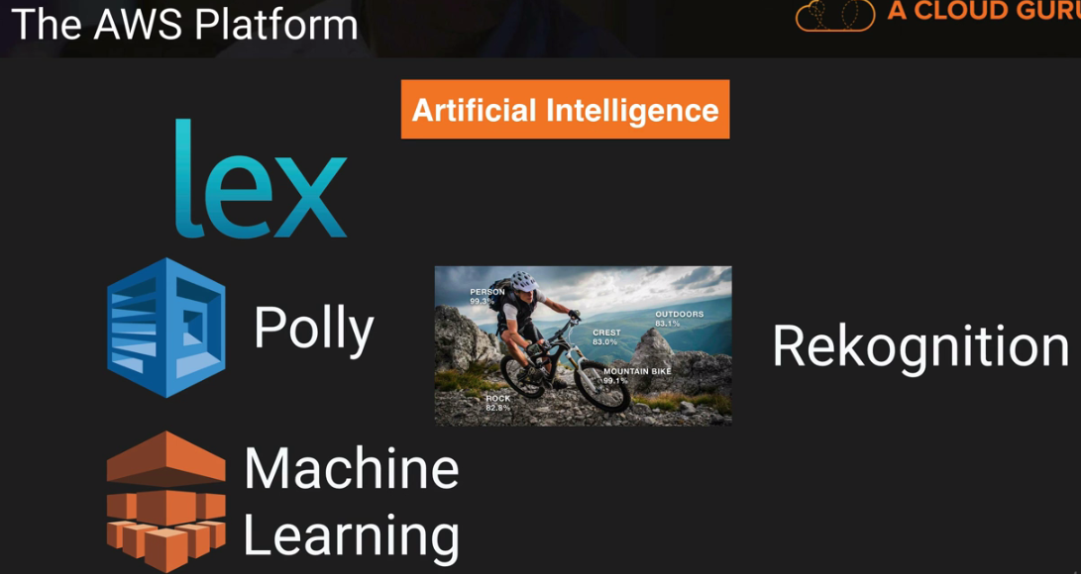 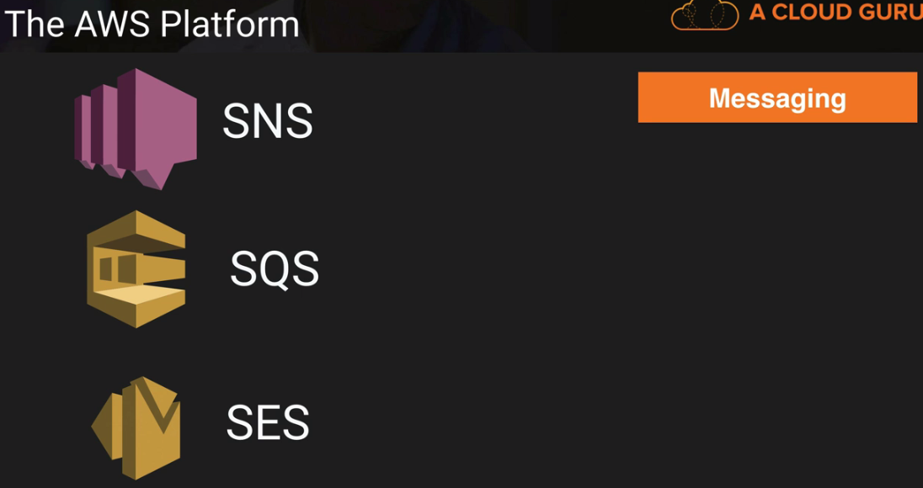

* **Elastic Beanstalk** automatically handle the deployment from capacity provisioning, load balancing, auto-scaling to application health monitoring based on the code you upload to it whereas **Cloud Formation** is an automated provisioning engine designed to deploy entire cloud environment via a JSON.
* **IAM** is Global i.e. if you create a user/role in IAM, it will be available globally.

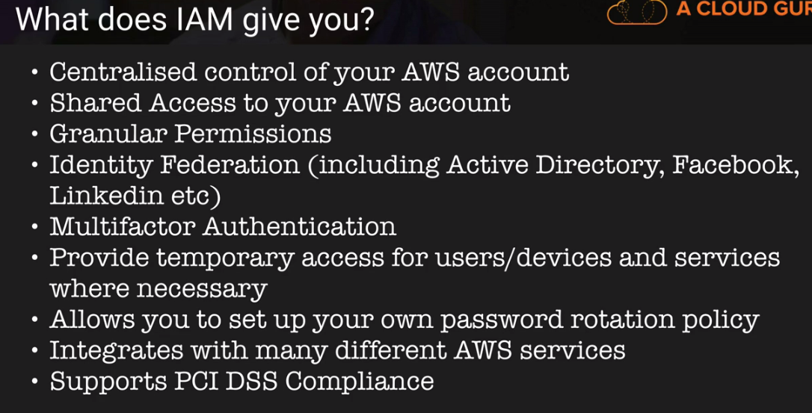

* **Root Account** is created with AWS account and it has complete admin access. **Power User** Access allows accesses to all AWS services except for management of groups and users within IAM. Role can be of 3 types:

1. **AWS Service Roles** are for AWS services to access other AWS service
2. **Cross Account Access** is used for accessing one account from other.
3. **Identity Provider Access** is used to interact with Facebook or Linkedin.

* When a new User is created, it does not have any access to any AWS services. Multi factor authenticate is authentication with physical or virtual device on PC or Phone.
* You can log in to the AWS console using password only while to access from sdk, use Access Key Id and Secret Access Key.
* Policy example:{ "Version": "2012-10-17", "Statement": [ { "Effect": "Allow", "Action": [ "s3:CreateBucket ], "Resource": "arn:aws:s3:::dms-*" } ] }
* To setup billing alarm. Goto Name>MyBilling Dashboard>Enable Alarm>Save Preference>Manage>Gotot CloudWatch> Billing > Set Alarm>Confirm email address.
* There are two types of storage Object/file Based Storage and Block Based Storage (where you can install OS or can be shared within n/w.). S3 is object based storage while EFS and EBS are block based storage.
* File size can be from 0 Byte to 5 TB in S3. The largest object that can be uploaded in a single PUT is 5 gigabytes. For objects, larger than 100 megabytes, customers should consider using the Multipart Upload capability. S3 provide unlimited file storage in buckets. S3 is universal namespace, that is, bucket cannot be named same as of bucket of another person. The URL pattern is:

https://s3-<domain>.amazonaws.com/<bucket-name>

* S3 is eventual consistence for modify/delete operation while you can read file immediately after write into S3. But its atomic, that is, either you’ll get old data or new data but not corrupted data.

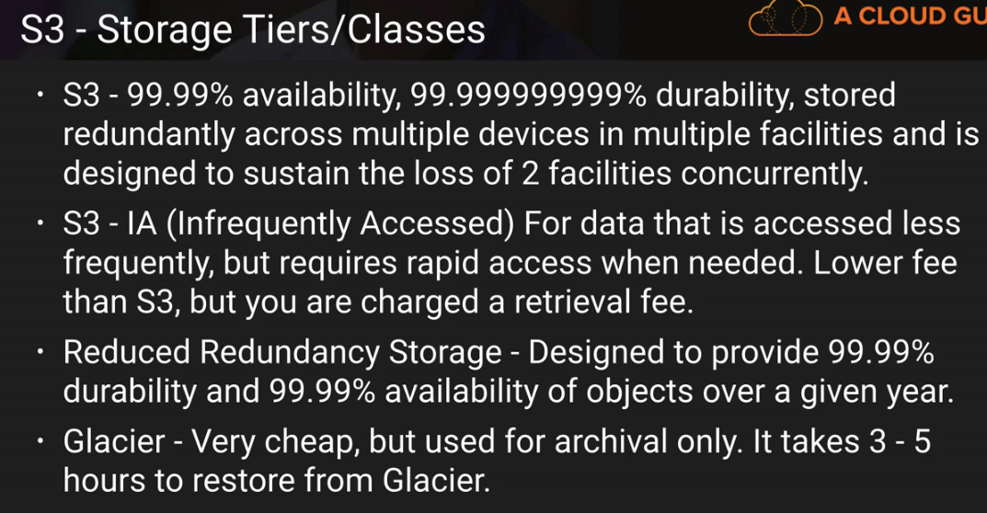

* **S3** is built for 99.99% Availability and 11*9’s (2 before decimal) durability and sustain the loss of 2 facilities concurrently. On the other hand, Reduced Redundancy can tolerate 1 concurrent facility failure.
* **S3- IA**, availability SLA is 99% against 99.9%, minimum object size is 128KB and retrieval fee is for per GB. To move object in IA, it needs to be 128Kb in size and 30 days old. But if you don’t enable archiving to S3-IA, you can move object to Glacier next day you upload to S3.
* In S3, data is stored in **KEY’s** alphabetically order geographically so if you store log files named start with same format, these files will be stored in same area which will impact S3 performance.
* **Glacier** stores data as little as $0.01 per Gb per month but retrieval time is 3-5 hours. Glacier is designed to keep object 90 days minimum. So even if object is deleted before, 90 days’ charge will be applicable.
* Amazon **S3 Transfer Acceleration** enables fast, easy and secure transfer of files over long distances by taking advantage of Amazon **Cloud Front** globally distributed edge locations
* S3 provide **AES-256** server side encryption where data will be encrypted before storing in S3.
* In S3, there are two type of permission management:

1) Manage User for users present in IAM

2) Manage Public permission for AWS users or public.

* By default, all the buckets and object in S3 are privately access until you provide access. In S3, there are two type of access granted:

1) Objects which allows to create/modify/delete objects in bucket

2) Object Permission which allows to grant permissions of create/modify/delete to other users also.

Even you enable everyone read for bucket, for each object you need to enable it.

* **Once versioning is enabled** in S3, it cannot be removed unless you delete the bucket though it can be disabled/suspended.
* While designing system for most cost-effective ways with very large files, we might want versioning disable as if file is of 4GB and we change this slightly, total storage in S3 will be 8GB for single file.
* If you delete version, it cannot be restored but if you delete any object in S3, it can be restored by removing the marker of delete operation from old view if versioning is enabled.
* **For cross region replication**, versioning should be enabled in both buckets and same region replication is not allowed. While enabling cross region replication, only new object replicate. Existing elements will not. But if you update an existing object, it will replicate all previous version also in destination bucket. Even permissions are replicated.
* You can’t replicate to two different buckets as well as A->B->C. The object will be replicate in C, only if, objects are written to B manually.
* If you delete any element from bucket, deletion will be replicated to another bucket. But if you delete "Delete Marker", your object will be restored in main bucket but will not in replicated bucket. The same is valid for version also. If you remove any version from main bucket, you can still restore that version from destination bucket.
* Lifecycle can be done with versioning on/off. For S3 Lifecycle management, if you select "**Action on current version**" and delete, it will put a delete marker but if you select "Action on previous version" and select delete. It will delete object permanently.
* By default, TTL is **24 hours** in edge locations. You can clear the data before that time, but it will be charged.

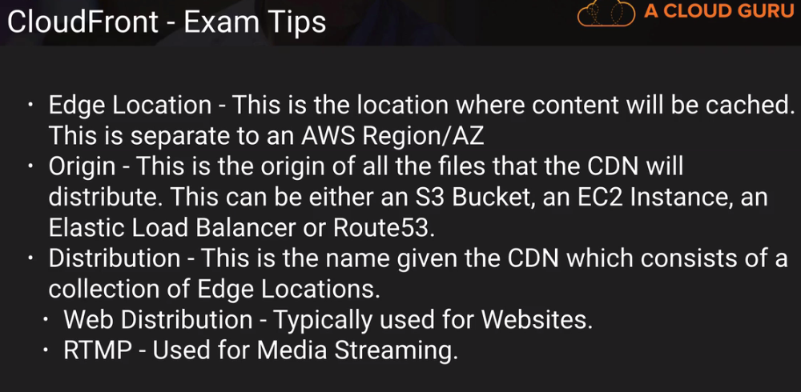

* S3 can be configured to log every request to S3 in another bucket. There are two types of encryption:

1. **In-transit** i.e. while upload/download from the S3 to local which is managed by SSL/TSL
2. **At Rest** where we have Server side encryption in 3 different flavors:
3. **S3 Managed Key** SSE-S3 where S3 managed key as well as master key to encrypt keys with ASC 256.
4. **Key Managed Service**, SSE-KMS where keys are protected with envelop keys generated uniquely for region as well as we get order trail of S3 bucket decryption usage.
5. **Customer Provided key** SSE-C where keys are provided by user.
6. **Client side** Encryption

* There are 4 types of **Storage Gateway**:

1. **File Gateway(NFS)** to store flat files into S3, accessed through a Network File System(NFS) mount point. Ownership and permission stored as object metadata in S3.
2. **Volumes Gateway(iSCSI)** is used to stored block based storage. These can be backed up asynchronously as EBS snapshot incrementally on cloud. These can be of 2 types:
3. **Stored Volumes** (Gateway stored volumes) to store copy of entire dataset to on premise. Back up EBS snapshot can be 1 GB-16 TB iSCSI in size.
4. **Cached Volumes** (Gateway cached volumes) to store most recent access data. 1GB to 32 TB in size.
5. **Tape Gateway(VTL)** (Gateway virtual tape library) to store archive data in virtual tapes which can be transferred to S3 and Glacier. It uses popular applications like Netbackup, Backup Exec, Veam etc.

* **AWS Import/export** was used to transfer data to AWS with physical disk but problem, was there were many disk types so AWS comes with **Snowball (80 TB)** or **Snowball Edge (100 TB)**. These can be used to import/export data from S3. If you want to transfer data from Glacier, It has to be transferred first to S3.
* **S3 Transfer Acceleration** utilizes Cloud Front Edge network to faster data upload to S3 with separate URL: **<bucket>.s3-accelerate.amazonaws.com**
* When you enable Static Website hosting URL looks like: http://<bucket-name>.s3-website-<region>.amazonaws.com
* RTMP distribution speeds up the distribution of your streaming media files using Adobe Flash Media Server's RTMP protocol. A single distribution allows to have different origin which can be distinguish with origin id. Smooth Stream service is used to Microsoft Smooth Stream APIs.
* Restrict Viewer Access (Use Signed URLs or Signed Cookies) allowed your content to be viewed by specific group of users.
* If Spot instance is terminated by AWS, you will not be charged for a partial hour of usage but if you terminate the instance yourself, you will be charged for that partial hour.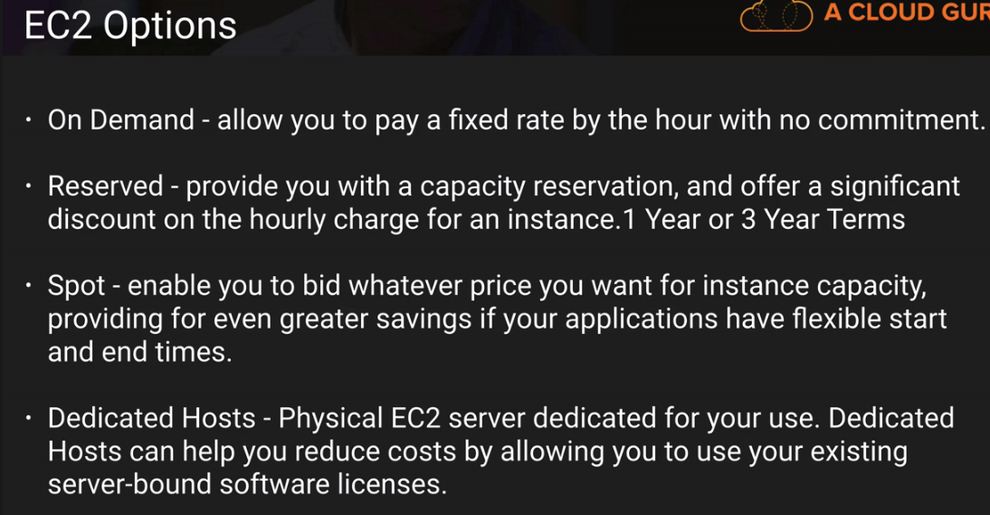 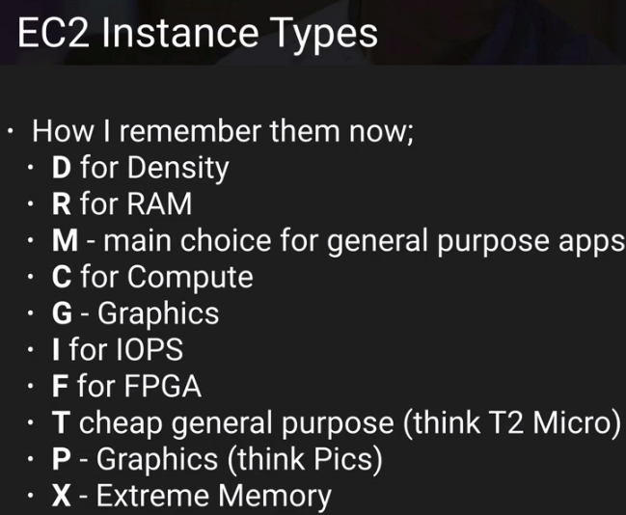
* AMI are regional, you can launch AMI from the region where it is stored. Though you can copy AMI’s to another region.
* To login into Linux EC2 instance, use **ec2-user**@<IP address> as address while public DNS for EC2 instance look like ec2-<IP separated by - in place of .>.<region>.compute.amazonaws.com. While with Window EC2 instance, username is **administrator**
* **EBS** are virtual Hard disks. Volumes exists on EBS. EBS volumes are placed in specific **same** availability zones where they are automatically replicate to protect you from failure. One EBS volume cannot be mounted with multiple EC2 or EC2 instance from another Availability Zone. In these case, EFS is better. In EFS, permission can be declared at file and folder level.
* If you need more than 10K IOPS(I/O operations per second), Provisioned IOPS SSD (IO1) is better than General Purpose SSD (GP2) which support 3 IOPS per GB with upto 10000 IOPS. HDD EBS disk can be used for processing sequential data.

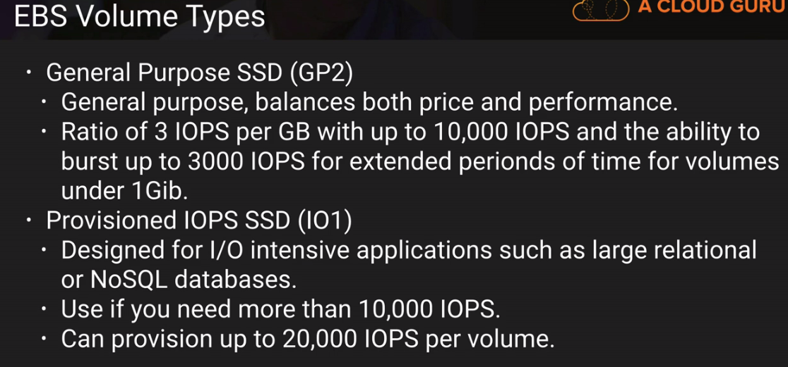 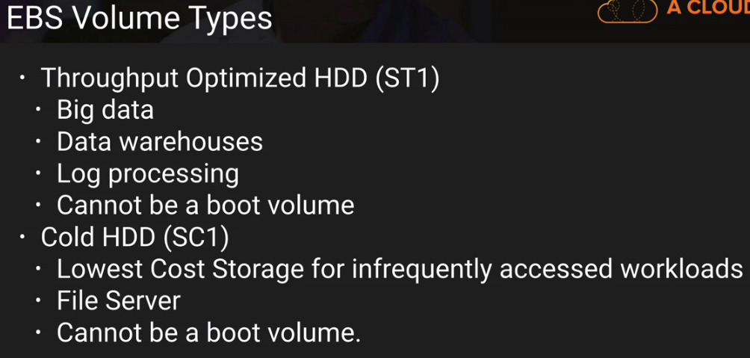

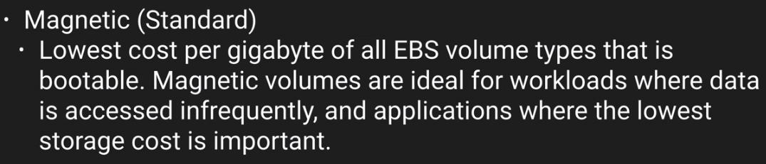

* Termination Protection is turned off by default for EC2 instance.
* By default, root EBS volume is deleted when the instance is terminated. With EBS backed EC2 instance, you can tell AWS to keep the root device volume but the same is not possible for Instance Type volume backed EC2 instances. EBS root volume of default AMI cannot be encrypted. It can be done when creating AMI’s. Instance Type volume cannot be detached and reattached again.
* We cannot delete a snapshot of an EBS Volume that is used as the root device of a registered AMI. You must deregister the AMI before being able to delete the root device.
* When you provision any new Security Group, all inbound traffic is blocked while all outbound traffic is allowed by default. You can specify allow rules only in Security Group. Security groups are Stateful so if you allow http inbound traffic, by default outbound traffic on http will also open, while Network Access List are stateless.
* **Snapshots** are copy of hard-disk at given point of time. They are stored in S3. Every time you take a snapshot of a Volume, only incremental changes will be stored in S3. While recreating Volume from snapshot, you can change the type of Volume.
* The best practice to take snapshot is to stop the EC2 instance and then take snapshot.
* Command to create the snapshots using the command line tools : ec2-create-snapshot
* Snapshots of encrypted volumes are encrypted automatically. Volumes restored from encrypted snapshots are also encrypted automatically. Only encrypted snapshots can be shared.
* **RAID** are collection of disk which can be worked as single Volume. This can be used when highest disk space available is not enough for your case. The main purpose of RAID is to improve IO. RAID 5 is collection if 3 or more volumes. For example, if you want to use some database like Casandra which is not supported by AWS.

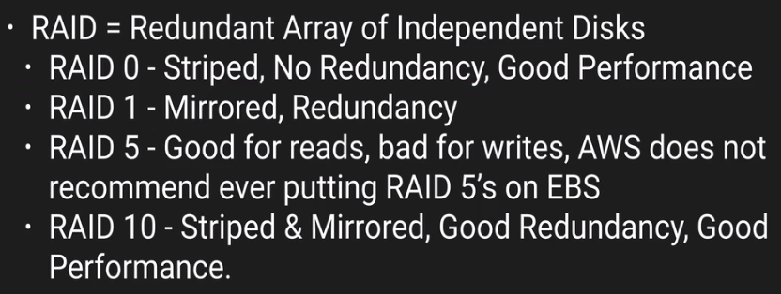

* EC2 with volume type **Instance Store (Ephemeral Storage),** you can add more than 1 Instance Volume bit before it’s launched. One you launch that instance; you can add only EBS instances to it. The root device for Instance Store Volume backed EC2 instance is created from a template stored in Amazon S3. As Instance store templates are stored in S3, it will take more time to start EC2 instances.
* You cannot stop the EC2 instance with Instance Store volume type. You will lose the data. But we can reboot these instances. EC2 Instance stop is required if underlying **Xen hypervisors** is failed and need instance restart to reassign.
* **Load Balancer** are not getting Public IPs like EC2 Instances. So ELB can be accessed by DNS only. There are two type of load balancer:

1. **Application Load Balancer** are preferred over classic load balancer. It does routing on Application layer.
2. **Classic Load Balancer** does routing on TCP Layer.

* **SSL Termination** on Load Balancer is supported so that your application wouldn’t have to worry about decrypting it. It also allows to identify originating IP address of client. For ELB, Response time is time wait in receiving response, it can be 2-60 sec. Interval is time between 2 consecutive checks, it can be 5-300 sec. Unhealthy threshold, no. of consecutive failure before declaring EC2 instance unhealthy.
* **CloudWatch** provides Dashboard, Alarms, Events and Log monitoring. By default, AWS support 4 kinds of metrics: 1) Disk, 2) CPU, 3) Network and 4) Status Check. Standard Monitoring is always in 5 minute while detailed monitoring is also in 1 minute. CloudWatch monitors the EC2 environment while **CloudTrail** audit them. You need to create custom metrics for **Memory Usage**.
* **System Status Check** verifies that your instance is reachable. If this check fails, there may be an issue with the infrastructure hosting your instance (such as AWS power, networking or software systems). This check does not validate that your operating system and applications are accepting traffic. **Instance Status Check** verifies that your instance's operating system is accepting traffic. If this check fails, you may need to reboot your instance or make modifications to your operating system configuration.
* An EC2 instance can only be assigned one role, **IAM role** attached EC2 instance, remain attached with instance until it’s deleted. We can attach a new IAM role to EC2 instance after it is created, only through command line not using console. But we can replace attached IAM role.
* Any rule change apply to Security Group applies immediately and if you allow any port in inbound, that port will be allowed for outbound by default.
* To get EC2 instance metadata, curl http://**169.254.169.254**/latest/**meta-data** URL in instance.
* **Placement Groups** is logical grouping of instances within a single Availability Zone. It is used for low network latency of 10 Gbps like for Casandra database which need fast network operations.

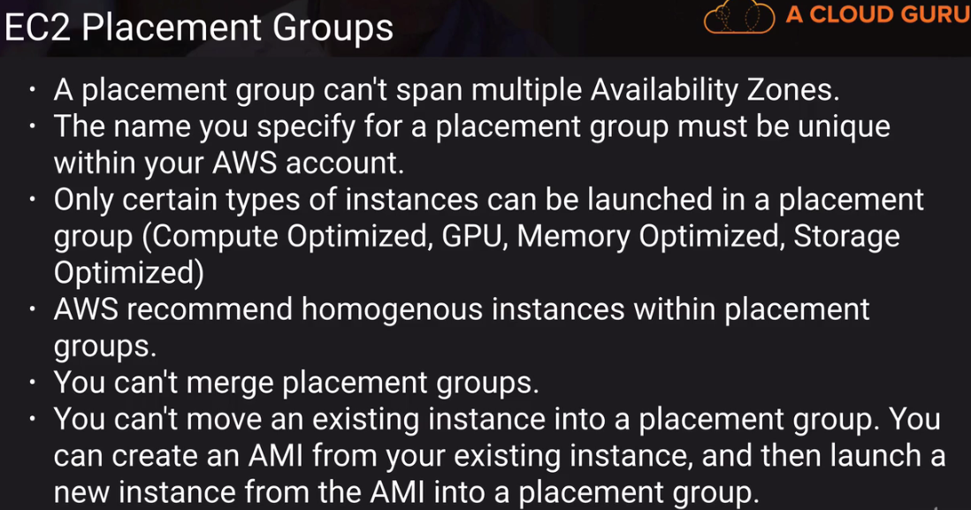

* AWS management reevaluate the **strategic business plan** for Risk at least biannually.
* **EFS** supports **NFS version 4** protocols and allows thousands of concurrent NFS connections. Consistency is **Read after write**. Data is stored in multiple AZ within a region. Pay as per use and scale up to petabytes. To attach EFS with EC2 Instances, we should select same security groups in both service.
* **Lambda** provides 1 million free requests. $0.20 per million request thereafter. You are charged $0.00001667 for every GB-second used.
* **Route53** is a global service. SOA Records stores: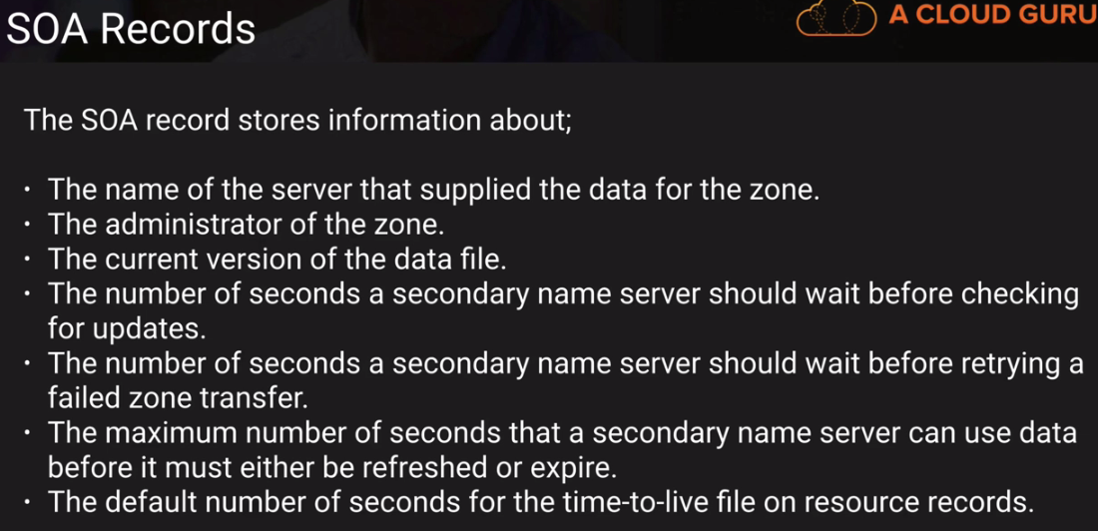
* **NS stands** for **Name Server** records and are used by Top Level Domain servers to direct traffic to the Content DNS server which contains the authoritative DNS records. For each registered domain, AWS creates Hosted Zones and 2 record sets: **NS and SOA** (start of authority) records
* An **“A” record** is fundamental DNS record and “A” stands for “Address”.
* A **Canonical Name (CName)** can be used to map one domain name to another. A **CName** can’t be used for naked domain names (zone apex) like <https://acloud.guru>. If you use **CName** in Route53 for routing, you will be charged for that. The other option is **Alias** where you are not charged.
* **Alias** records are used to map resource record sets in your hosted zone to elastic Load Balancers, CloudFront distribution, or S3 buckets that are configured as website. It can save you time because Route 53 automatically recognizes changes underlying.
* Route 53 has following Routing Policies: 1) Simple 2) Weighted 3) Latency 4) Failover(Active/Passive) 5) GeoLocation.
* For **weighted routing**, you can define weight from 0 to 255 and create one “A” record for each weight. AWS will determine the percentage and route n/w accordingly.
* **Latency based routing** allows to route your traffic based on the lowest network latency for your end user.
* Route 53 support **MX Records**. A mail exchanger record (MX record) is a type of resource record in the Domain Name System that specifies a mail server responsible for accepting email messages on behalf of a recipient's domain, and a preference value used to prioritize mail delivery if multiple mail servers are available.
* In Route53, we can manage **50 domain names** by default, however it is a soft limit and can be raised by contacting AWS support.
* To use an S3 bucket for Route 53 DNS failover, the bucket name must match the domain name.
* Online Transaction Processing (OLTP) pulls rows from data while Online Analytics Processing (OLAP) runs some analytical query to get specific values in Data warehouse.
* Restored version from **Automatic Backup** or manual snapshot, will be new RDS instances with a new endpoint. Automatic Backup allows you to recover your database to any point in time within a “retention period” which can be 1 to 35 days. Backups stored in S3 and your DB size equal space is free. **Snapshots** are stored even after you delete the DB unlike Automatic Backup.
* **Encryption** is supported for MySQL, Oracle, SQL Server, Postgres and MariaDB. Once encryption is enabled, underlying data, automatic backups, read replicas and snapshots are encrypted also. Encryption for old DB is not supported.
* **DynamoDB** offers **push button** scaling while to scale up the RDS database, take snapshot and while restore specify storage type of higher capacity. Same as for enabling encryption. You cannot select a specific **Availability Zone** in which to place your **DynamoDB** Table.
* **Multi AZ** is only for disaster recovery only. It’s not primarily used for improving performance. For performance improvement, you need **Read Replicas** of database. Read replica support 5 replicas for single database. Read replica is supported for Postgres, MySQL and MariaDB. Read replicas has its own DNS server. You cannot have Read Replica of Multi-AZ. Read replica can be promoted to its own database but it will break replication. Alternatively, you can use a **sharding** algorithm that routes the data where it needs to be.
* **DynamoDB** store data on SSD and its spread across 2 geographically distinct data centers. It supports 2 types of consistency model:

1. **Eventual Consistency Reads** (default)
2. **Strongly Consistency Reads**

DynamoDB charged $0.0065 per hours for 10 unit of write and 50 units of reads plus $0.25Gb per month.

* **Redshift** is a fully managed service. It supports Columnar Data Storage; Advanced compression as same datatype data is stored together and Massive Parallel Processing. In transit, data is secured using SSL and at rest using AES 256. It’s available in 1 AZ but can store snapshots in new AZ’s. Redshift uses 1024KB/1MB as block size for its columnar storage.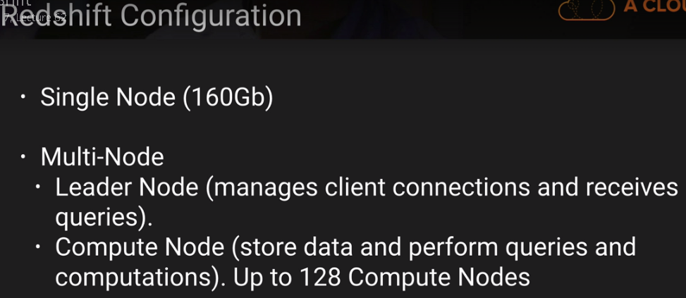 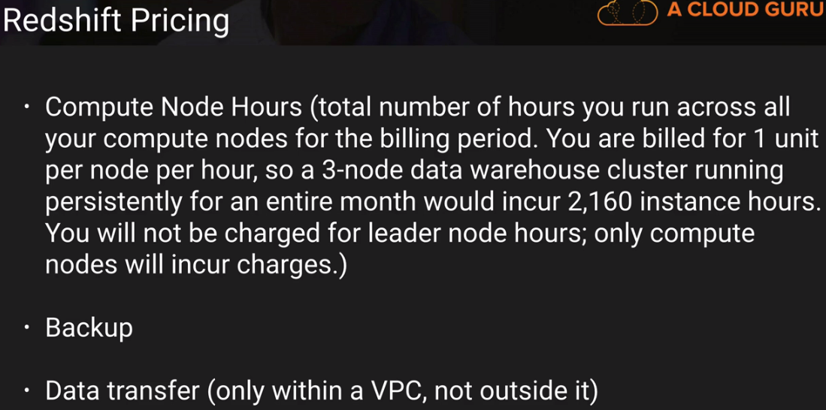
* **Aurora** provides up to 5 times better performance than MySQL at a price point one tenth of a commercial database. If you lose primary DB server, with Aurora Replicas (15), it will do the failover but with MySQL Read Replicas (5), it will not. Aurora database starts with 10 Gb storage, scale in 10Gb increments up to 64 Tb. Compute resources can scale up to 32vCPUs and 244Gb of memory.
* **Aurora** keeps 2 copies of your data in each AZ with minimum of 3 AZ. So, total 6 copies of data with handling loss of up to 2 copies of data without affecting write availability and loss of 3 copies of data without affecting read availability. Its self-healing.
* If you are using Amazon RDS Provisioned IOPS storage with MySQL and Oracle database engines 6TB is the maximum size RDS volume and 30,000 IOPS capacity, you can have by default
* DB Instance with Priority tier 0 becomes master copy. **Primary DB** instance is always accessed by **cluster DNS** while other can be accessed by instance DNS address.
* **Elastic Cache** supports Master/Slave replication and Multi AZ which can be used to achieve cross AZ redundancy.
* **Elastic Cache** is a good choice if your database is read heavy and not prone to frequent changes while Redshift is useful if database is feeling stress because of heavy OLAP transaction on it.
* When you create **VPC**, it creates Network ACLs, Security Group and Route Tables by default. If you delete default VPC, only way to bring it back is to contact AWS. 5 VPC's are allowed in each AWS Region by default.

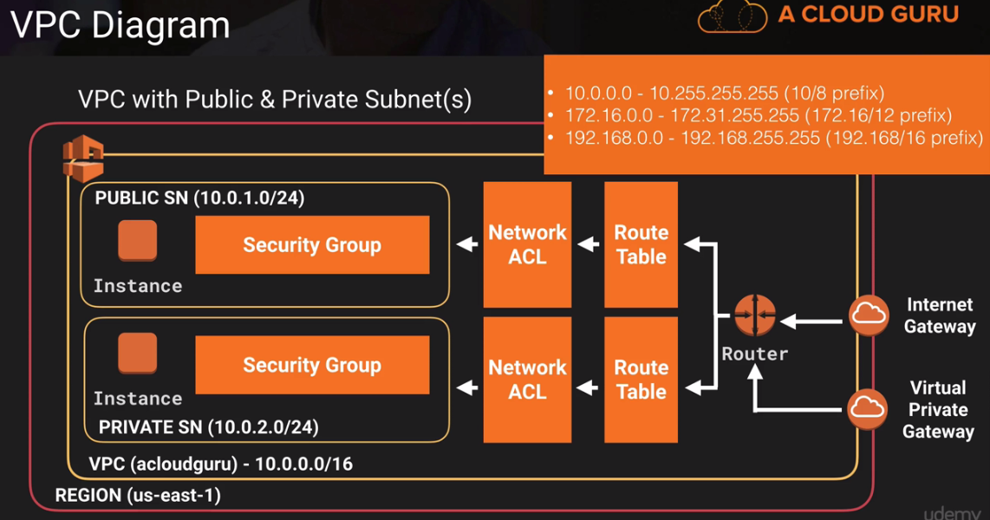

* 1 **subnet** can be attached to one AZ as well as one Network ACL only. If you add any subnet to one ACL, it will be removed from Network ACL which was created with VPN. So, to create high available system, we should have 2 publicly available subnet in 2 different AZs. It cannot be spanned to multiple AZ. By default, AWS reserves 251 IPs for any new subnet. AWS reserves 5 IP addresses for their operation:

1. 10.0.0.0: Network address
2. 10.0.0.1: Reserved for VPC router
3. 10.0.0.2: Reserved for DNS IP address, as its base of VPC network range plus 2
4. 10.0.0.3: Reserved for future use
5. 10.0.0.255: Network broadcast address, VPC does not support broadcast.

* You cannot attach multiple Internet gateway to VPC.
* AWS provides **Elastic IPs** which can be associated with any EC2 instances. Deploy any EC2 instance in public subnet does not allow internet. You need to define Elastic IP or Elastic Load Balancer. Even if you create inbound and outbound rule, you cannot access public subnet until you open the Ephemeral Ports on 1024-65535.
* **NAT Gateway** and **NAT Instance** can be used to provide access to private subnet securely. NAT Gateway is new and auto scalable as well no need to define Security Group. For NAT instance, we need to disable Source Destination Check. NAT Gateway scale automatically up to 10 Gbps. Not associate with SG and assign public IP automatically.

|  |  |  |
| --- | --- | --- |
| **Attribute** | **NAT gateway** | **NAT instance** |
| Availability | Highly available. NAT gateways in each Availability Zone are implemented with redundancy. Create a NAT gateway in each Availability Zone to ensure zone-independent architecture. | Use a script to manage failover between instances. |
| Bandwidth | Supports bursts of up to 10Gbps. | Depends on the bandwidth of the instance type. |
| Maintenance | Managed by AWS. You do not need to perform any maintenance. | Managed by you, for example, by installing software updates or operating system patches on the instance. |
| Performance | Software is optimized for handling NAT traffic. | A generic Amazon Linux AMI that's configured to perform NAT. |
| Cost | Charged depending on the number of NAT gateways you use, duration of usage, and amount of data that you send through the NAT gateways. | Charged depending on the number of NAT instances that you use, duration of usage, and instance type and size. |
| Type and size | Uniform offering; you don’t need to decide on the type or size. | Choose a suitable instance type and size, according to your predicted workload. |
| Public IP addresses | Choose the Elastic IP address to associate with a NAT gateway at creation. | Use an Elastic IP address or a public IP address with a NAT instance. You can change the public IP address at any time by associating a new Elastic IP address with the instance. |
| Private IP addresses | Automatically selected from the subnet's IP address range when you create the gateway. | Assign a specific private IP address from the subnet's IP address range when you launch the instance. |
| Security groups | Cannot be associated with a NAT gateway. You can associate security groups with your resources behind the NAT gateway to control inbound and outbound traffic. | Associate with your NAT instance and the resources behind your NAT instance to control inbound and outbound traffic. |
| Network ACLs | Use a network ACL to control the traffic to and from the subnet in which your NAT gateway resides. | Use a network ACL to control the traffic to and from the subnet in which your NAT instance resides. |
| Flow logs | Use flow logs to capture the traffic. | Use flow logs to capture the traffic. |
| Port forwarding | Not supported. | Manually customize the configuration to support port forwarding. |
| Bastion servers | Not supported. | Use as a bastion server. |
| Traffic metrics | Not supported. | View CloudWatch metrics. |
| Timeout behavior | When a connection times out, a NAT gateway returns an RST packet to any resources behind the NAT gateway that attempt to continue the connection (it does not send a FIN packet). | When a connection times out, a NAT instance sends a FIN packet to resources behind the NAT instance to close the connection. |
| IP fragmentation | Supports forwarding of IP fragmented packets for the UDP protocol. Does not support fragmentation for the TCP and ICMP protocols. Fragmented packets for these protocols will get dropped. | Supports reassembly of IP fragmented packets for the UDP, TCP, and ICMP protocols. |

* Through NAT instance, private subnet EC2 instance can access internet but people from internet cannot access (SSH) into these systems. For this purpose, Bastion is used.
* Network ACL created with VPC by default allows all inbound/outbound traffic but if you create any custom Network ACL, inbound/outbound traffic is denied. Network ACL rules are executed in order. They are not overrides. To block any IP addresses, we can use Network ACL's not Security Group. NACL are applies to all instances in subnet while SG, manually need to apply to each instance.
* **VPC Peering** allows you to connect one VPC with another via direct network route using private IPs. VPC Peering wouldn’t work if they have matching or overlapping CIDR (IP) block and if VPCs are in **different regions.** Peering does not support transitive peering relation b/w A and C if A->B and B->C.
* AWS support Active Directory with SAML authentication where you will be authenticated with Active Directory first then given temporary credentials.
* **VPC Flow logs** help all VPC network actions logging to CloudWatch.
* There are 2 types of SQS:

1. Standard Queue (default) allows you to have almost unlimited transection per second.
2. FIFO Queue deliver message once only. It’s limited to 300 transactions per second.

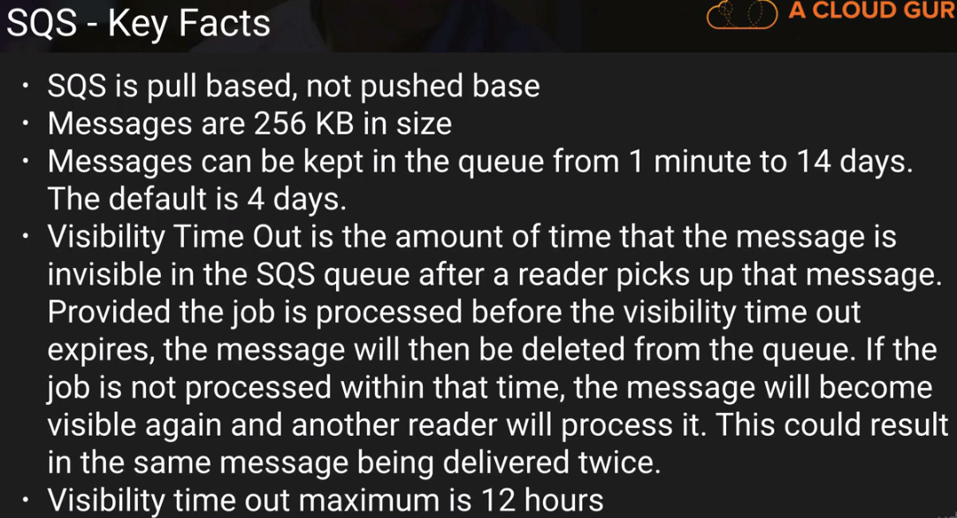

* **AWS SQS Long Polling** does not return until a message arrive or Long Polling times out (RecieveMessage WiatTimeSeconds) irrespective of regular polling, which returns immediately.
* There are 3 actors in **SWF** 1) Starters, 2) Deciders and 3) Workers. Domain is a collection of related workers.
* **SNS** can publish message to Mobile devices, SMS, emails, SQS, HTTP end points or Lambda function. Pay-as-you-go model with no up-front costs. $0.50 per 1 million requests, $0.06 per 100,000 HTTP notifications, $0.75 per 100 SMS and $2.00 per 100,000 emails.
* **AWS SWF** retain message for 1 year of workflow execution while SQS keeps it for 14 days. SWF is task oriented, ensure task is assigned only once and track all tasks and events.
* **Elastic Transcoder** convert media file per destination systems. Pay based on the minute that you transcode and the resolution at which you transcode.
* **API Gateway** is low cost, auto scale, enabled Caching for better performance, throttle to prevent attacks and can log result to CloudWatch.
* There are 2 types of Computing Policies in web application security:

1. **Same-Origin Policy**, script on first web page can access data from second page only if both are on same origin.
2. **Cross-Origin Resource Policy** (CORS), Error message “Origin policy cannot be read at the remote resources?”, you need to enable CORS on API Gateway.

* There are 3 types of **Kinesis services**:

1. Kinesis Stream, contain Shards
2. Kinesis Firehose
3. Kinesis Analytics, allows to run SQL query to analyze the data

* **Kinesis Streams** stores data for 24 hours by default but it can be increased to 7 days and data can be send to S3, EMR, Redshift and DynamoDB via EC2. Kinesis Stream supports 5 transactions per second for read, up to a maximum total data read rate of 2 MB per second and up to 1000 records per second for write, max of 1 MB per sec data write rate. On the other hand, kinesis firehose sends data to underlying S3, Redshift (via S3) and Elastic search cluster immediately with Lambda analytic optionally.
* Stream large amount of data in to the cloud, think **Kinesis**, processing large amount of data for business intelligence, think **Redshift** and process large data for Big Data Processing, think **Elastic Map Reduce**.
* Look for the term “chef” or “recipes” or “cook books” and think **OpsWorks**.
* In **consolidated billing**, paying as well as linked accounts are independent and paying account cannot access resources of the other account. Currently, you can link max 20 (soft limit).
* **Resource Group** contain information like Region, Name, Health Checks and Specific information like Public/Private IP for EC2, Port Configuration for ELB and Database Engine for RDS.
* In **Direct Connect,** customer office is connected to private Rackspace in Direct Connect (DX) Facility where it is connected to AWS Data center. It’s available in 10Gbps and 1Gbps. Uses Ethernet VLAN trunking (802.1Q).
* 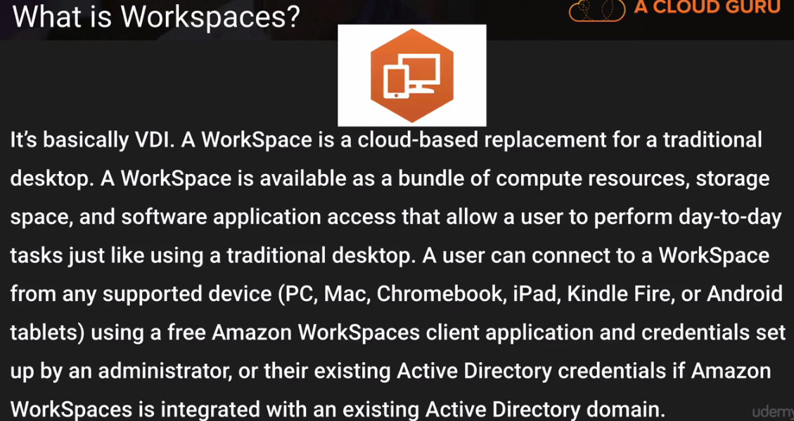

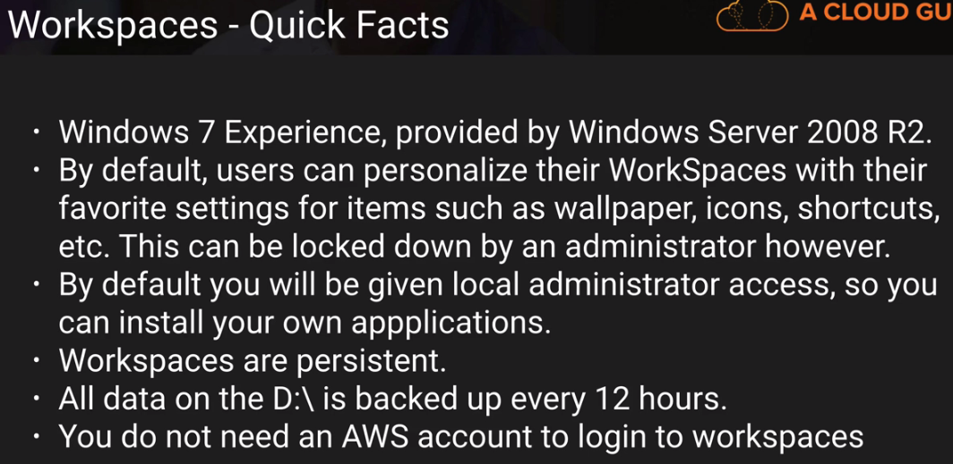

* AWS is responsible for the patching or antivirus of **managed service** products like DynamoDB, RDS, Redshift, Elastic MapReduce and Workspace. However, you are responsible for account management and user access. On the other hand, **IAAS**, like EC2, VPC and S3, are completely your control.
* Amazon provides following **Network Monitoring and Protection Technique**: DDos, Man in the middle attacks (MITM), IP Spoofing, Port Scanning and Packet Sniffing by other tenants.
* AWS provides following **credentials**: Passwords, Multi-Factor Authentication, Access Key, Key Pairs and X.509 Certification (for S3 SOAP based request). **Trusted Advisor** inspects your AWS environment and makes recommendations for save money, improve system performance and close security gaps.
* Amazon provide encryption of data as it moves between EC2 instance and EBS storage, called **EBS Encryption** with AES-256 but this feature is only available on EC2’s more powerful instance types (M3, C3, R3, G2) for low latency.
* AWS Security regularly scans all internet facing service endpoint IP addresses for vulnerabilities (not include customer instances). Customer can do their own vulnerability scan but needs to inform to AWS in advance.
* AWS import/export has three pricing components: a per-device fee, a data load time charge (per data-loading-hour) and possible return shipping. While Storage gateway has 4 pricing components: gateway usage (gateway per month), snapshot storage usage (per GB per month), volume storage usage and data transfer out.
* Elasticity can be implemented by three ways: Proactive cyclic Scaling, Proactive event (product launch, marketing campaign) based Scaling and Auto-Scaling based on demands.
* Amazon EC2 instance running Windows can use build-in Encrypting File System (EFS) feature which automatically encrypt or decrypt files and folders at file level not at file system level.
* There are 2 ways to use Amazon Glacier, API to directly store/retrieve archived data and through object lifecycle management. Note, if Objects archived to Glacier by S3, can only be listed or retrieved by Amazon S3 API not through Glacier API.
* Because of the way that Amazon EC2 virtualizes disks, the first write operation on an instance store volume performs more slowly than subsequent writes. For high disk performance, its recommended to write once to every drive locations before production use.
* There are 5 pillars of Well-Architected Framework: 1) Security 2) Reliability 3) Performance Efficiency 4) Cost Optimization 5) Operational Excellence.
* 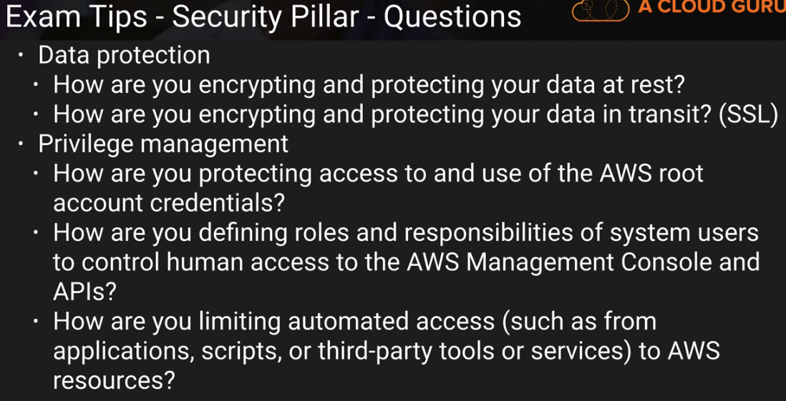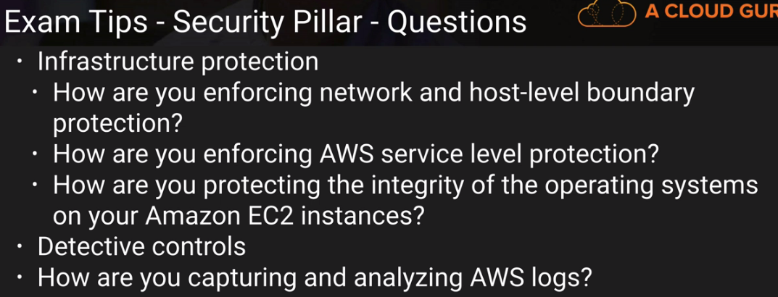
* 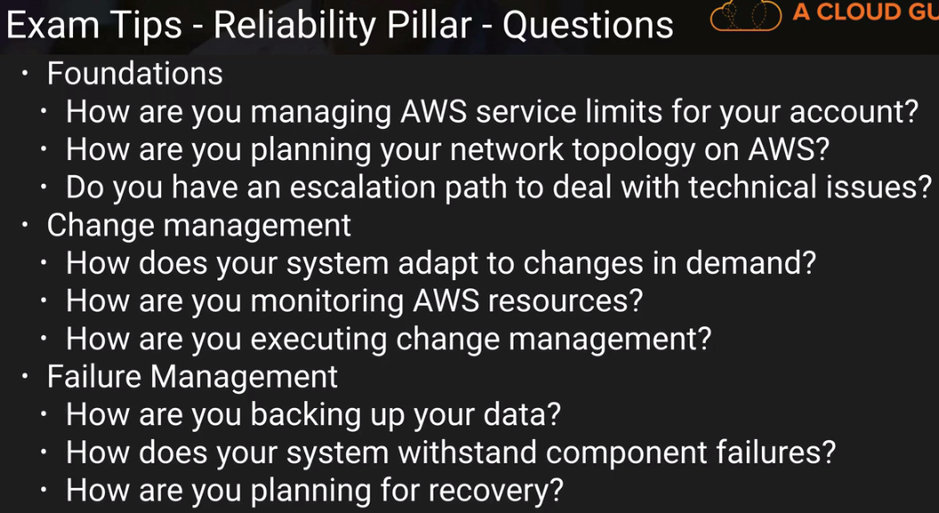
* 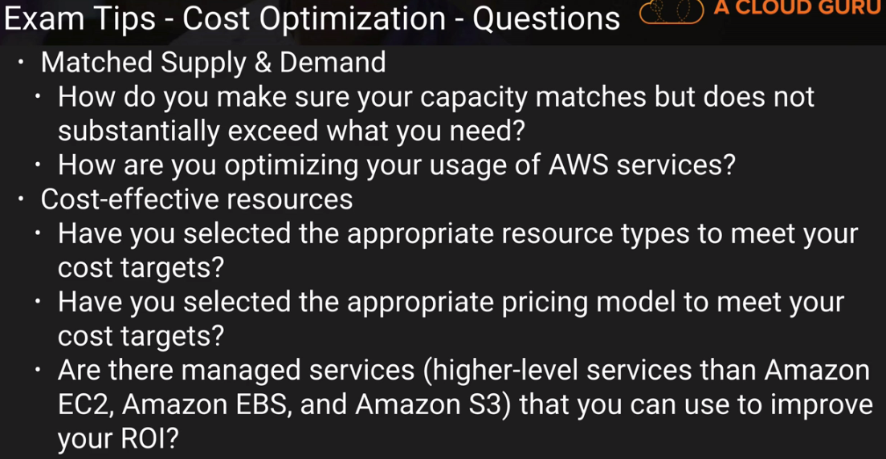 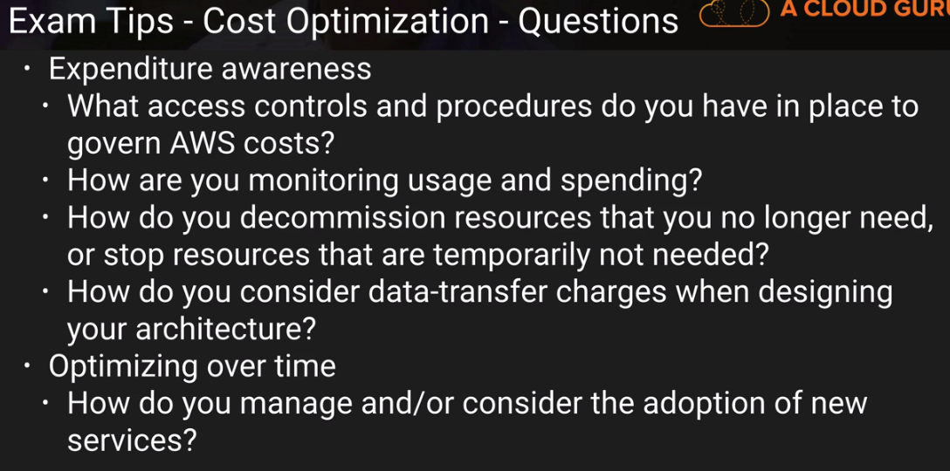
* 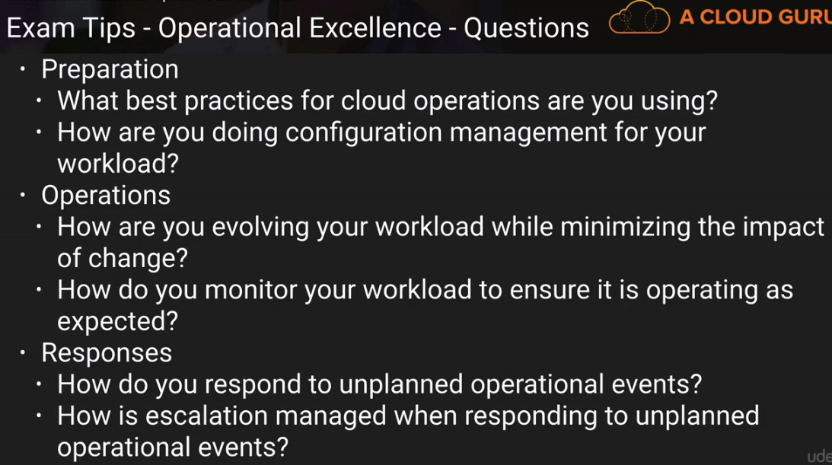
* **Runbook** guides operations teams for their normal daily tasks while **Playbooks** guide them in unexpected operational events.
* In RDS, changes to the backup window take effect immediately. In RDS, 10Gb per Database is the maximum size for a Microsoft SQL Server DB Instance with SQL Server Express edition. Amazon RDS does not currently support increasing storage on a **SQL Server** Db instance.
* If you want your application to check whether a request generated an error, then you look for an **Error** node in the response from the Amazon RDS API
* You cannot move a **reserved instance** from one **region** to another. But they can be migrated to another AZ. Reserved instance are available for multi-AZ deployments. You can terminate the reserved instances and AWS will automatically begin billing the two on-demand instances as reserved instances
* When trying to grant an amazon account access to S3 using access control lists you should use to identify that account with “the email address of the account or the canonical user ID” method of identification
* Elastic Map reduce allows you root access (ie you can login using SSH).
* Para-Virtual (PV) & Hardware Virtual Machine (HVM) are the different types of virtualization available on EC2.
* When you create new subnets within a custom VPC, by default they can communicate with each other, across availability zones.
* For all new AWS account, there is soft limit of **20 EC2 instances per region**.
* you cannot assign EC2 instances to a group, only AWS users can be assigned to a group in IAM.
* AWS does not copy launch permissions, user-defined tags, or Amazon S3 bucket permissions from the source AMI to the new copied AMI.
* Amazon Auto Scaling is not meant to handle instant load spikes but is built to grow with a gradual increase in usage over a short time-period.
* Kinesis can route related data records to the same record processor (as in streaming MapReduce).
* The AMI ID used in an Auto Scaling policy is configured in the LAUNCH CONFIGURATION
* **The KPL** is an easy-to-use, highly configurable library that helps you write to an Amazon Kinesis stream. It acts as an intermediary between your producer application code and the stream's API actions. One of its key concepts is aggregation. It refers to the storage of multiple records in a stream's record and allows customers to increase the number of records sent per API call, which effectively increases producer throughput
* You can leverage SQS as well as SWF to utilize both on-premises servers and EC2 instances for your decoupled application.
* The "**Owner**" refers to the identity and email address used to create the AWS account.
* Once a VPC is set to Dedicated hosting, it is not possible to change the VPC or the instances to Default hosting. You must re-create the VPC.
* **Route53** has a security feature that prevents internal DNS from being read by external sources. The work around is to create a EC2 hosted DNS instance that does zone transfers from the internal DNS, and allows itself to be queried by external servers.
* **DynamoDB** allows for the storage of large text and binary objects, but there is a limit of 400 KB combined.
* Customers may use four mechanisms for **controlling access to Amazon S3** resources: Identity and Access Management (IAM) policies, bucket policies, Access Control Lists (ACLs) and query string authentication. With ACLs, customers can grant specific permissions (i.e. READ, WRITE, FULL_CONTROL) to specific users for an individual bucket or object. With query string authentication, customers can create a URL to an Amazon S3 object which is only valid for a limited time.
* **The Standard - IA storage** class is set at the object level and can exist in the same bucket as Standard, allowing you to use lifecycle policies to automatically transition objects between storage classes without any application changes.
* When processing a retrieval job, Amazon S3 first retrieves the requested data from **Amazon Glacier**, and then creates a temporary copy of the requested data in RRS (which typically takes on the order of a few minutes). The access time of your request depends on the retrieval option you choose: Expedited, Standard, or Bulk retrievals. For all but the largest objects (250MB+), data accessed using Expedited retrievals are typically made available within 1 – 5 minutes. Objects retrieved using Standard retrievals typically complete between 3 – 5 hours. Lastly, Bulk retrievals typically complete within 5 – 12 hours.
* Many instances can poll a single queue, but to prevent multiple instances from processing the same SQS message, your application must delete the SQS message after processing it.
* You cannot **deny** the AWS root account to EC2 instances via IAM policy.
* . /28 is the smallest possible subnet in an AWS VPC.
* **Short polling** does not query all the servers that the SQS messages can reside on, so multiple queries of the queue may be needed to retrieve all messages in the queue.
* You are the system administrator for your company's AWS account of approximately 200 IAM users. A new company policy has just been introduced that will change the access of 50 of the IAM users to have unlimited access to S3 buckets. To implement this effectively so that there is no need to apply the policy at the individual user level, use the IAM groups and add users, based upon their role, to different groups and apply the policy to group.
* **A Classic Load Balancer** is ideal for simple load balancing of traffic across multiple EC2 instances, while an Application Load Balancer is ideal for microservices or container-based architectures where there is a need to route traffic to multiple services or load balance across multiple ports on the same EC2 instance. Application Load Balancer supports Host-based and Path-based Routings. Classic LB does not support IPv6 in VPC but supports load balancing for the following TCP ports:

[EC2-VPC] 1-65535

[EC2-Classic] 25, 80, 443, 465, 587, 1024-65535

* If you are using Amazon Virtual Private Cloud, you can configure security groups for the front-end of your Classic Load Balancers. Classic Load Balancers do not cap the number of connections that they can attempt to establish with your load balanced Amazon EC2 instances. Classic Load Balancers do not support instances launched using a paid AMI from Amazon **DevPay site**.
* 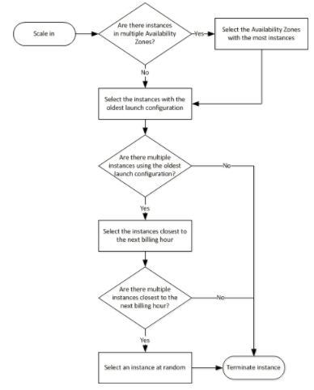
* Auto Scaling currently supports the following custom **termination policies**:
  + 1. **OldestInstance**. Auto Scaling terminates the oldest instance in the group. This option is useful when you're upgrading the instances in the Auto Scaling group to a new EC2 instance type, so you can gradually replace instances of the old type with instances of the new type.
    2. **NewestInstance**. Auto Scaling terminates the newest instance in the group. This policy is useful when you're testing a new launch configuration but don't want to keep it in production.
    3. **OldestLaunchConfiguration**. Auto Scaling terminates instances that have the oldest launch configuration. This policy is useful when you're updating a group and phasing out the instances from a previous configuration.
    4. **ClosestToNextInstanceHour**. Auto Scaling terminates instances that are closest to the next billing hour. This policy helps you maximize the use of your instances and manage costs.
    5. **Default**. Auto Scaling uses its default termination policy. This policy is useful when you have more than one scaling policy associated with the group.
* ELB health checks do not have to be performed on port 80. This is the default, yes, but it can be changed.
* **Pre-warming** is a process used when you are anticipating a spike in demand.
* **EBS Volume** must live in same availability zone as EC2 instance where you are attaching it.
* To enable **source traffic IP** in place of ELB in access logs on web server, Enable Access Logs to Amazon S3 (found under attribute).
* If you are unable to add any instance from a specific subnet in ELB, please check that subnet is added to that ELB.
* For **configuring VPC Peering**, you need to add Route tables also from other IPs to peering.
* An **AWS VPC connection** automatically has two parallel IPsec tunnels for redundancy. A Public Virtual Interface allows you to interface with AWS resources that have a public endpoint (like S3 or DynamoDB).
* **The Customer Gateway** is a physical or software application that is located at your on-premise data center. It is the VPN connector on the data center side (of the connection) and must be configured with a static public IP address.
* A **Virtual Private Network** is a great backup solution for AWS direct connect. A virtual private network provides the same access, just with fewer benefits. A VPN is what allows you to extend subnets inside your VPC to your on-premise data center.
* **The cross-network connection** is the connection between your on-premise data center and the Direct Connect Authorized Provider.
* In EMR, **master node** distributes the data as well as tasks and track them while Slave Core node runs task and “heavy lifting”/store data to HDFS and Task node runs only task (they are optional).
* Roles are used to acquire specific permissions by AWS resources like EC2 or non AWS IAM users (using SAML) as policy cannot be attached directly to them.
* Your **"default**" VPC already has an IGW attached. Only 1 IGW can be attached to VPC at a time and IGW cannot be detach from VPC if it has some active resources.
* Placement Group throws "insufficient capacity error" if new instances are added later or PG is stopped and started again. To resolve this error, stop and start all member instances.
* Volumes created from **an EBS snapshot** must be initialized. Initializing occurs the first time a "storage block on the volume is read" - and the performance impact can be impacted by up to 50%. You can avoid this impact in production environments by manually reading all the blocks.
* **IOPS** are measured in size of 256KB "chunks".
* **S3 generates events** for RRSObjectLost, ObjectCreated (Put, Post, Copy, CompleteMultipartUpload) and can be sent to SNS, SQS and Lambda.
* When you suspend object versioning, all existing objects retain their current and past versions, and no new versions are created when updated object are uploaded.
* **CloudHSM** (Hardware Security Module) is a dedicated physical machine isolated to store security keys and other encryption keys. If you lose these keys, these cannot be restored.
* **Perfect Forward Secrecy,** **which uses session keys that are ephemeral and not stored anywhere,** is used to offer SSL/TLS cipher suites for CloudFront and Elastic Load Balancing.
* 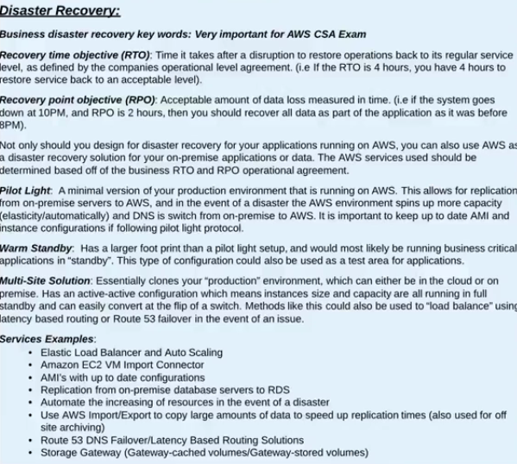
* To control who is able to download objects from Amazon CloudFront edge locations, the service uses a signed-URL verification system. To use this system, you first create a public-private key pair, and upload the public key to your account via the AWS Management Console. Second, you configure your Amazon CloudFront distribution to indicate which accounts you would authorize to sign requests – you can indicate up to five AWS Accounts you trust to sign requests. Third, as you receive requests you will create policy documents indicating the conditions under which you want Amazon CloudFront to serve your content. These policy documents can specify the name of the object that is requested, the date and time of the request, and the source IP (or CIDR range) of the client making the request. You then calculate the SHA1 hash of your policy document and sign this using your private key. Finally, you include both the encoded policy document and the signature as query string parameters when you reference your objects. When Amazon CloudFront receives a request, it will decode the signature using your public key. Amazon CloudFront will only serve requests that have a valid policy document and matching signature.